**Project Design Phase - II**

**Data Flow Diagram**

|  |  |
| --- | --- |
| Date | 14 October 2022 |
| Team ID | PNT2022TMID52758 |
| Project Name | Project - Industry Specific Intelligent Fire Management Studies |
| Maximum Marks | 4 Marks |

**Data Flow Diagram:**

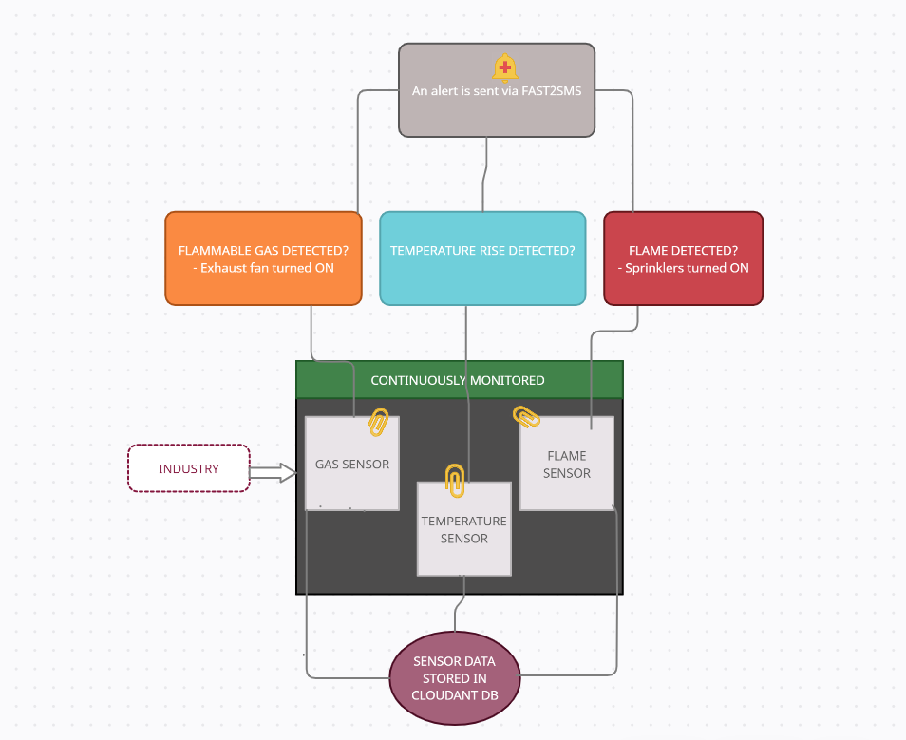

**TEAM LEADER:**

HARSHAVARTHANA M (1904012)

**TEAM MEMBERS:**

AMIRTHAVARSHINI R (1904001)

ATCHAYA B (1904004)

RAGHAVI R (1904038)

RAKSHEKA R (1904039)